Grocery Server Port

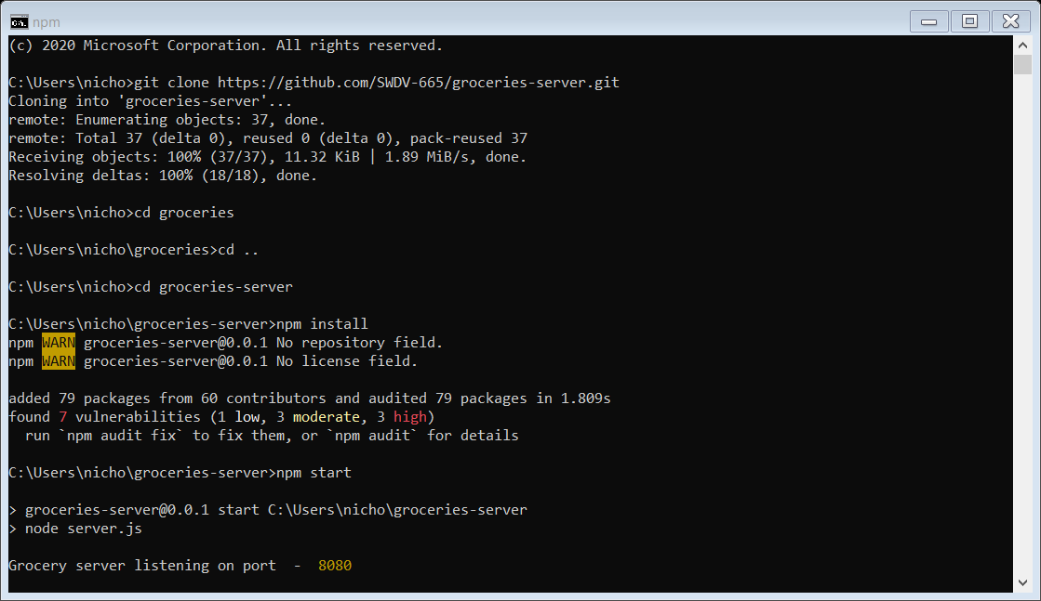

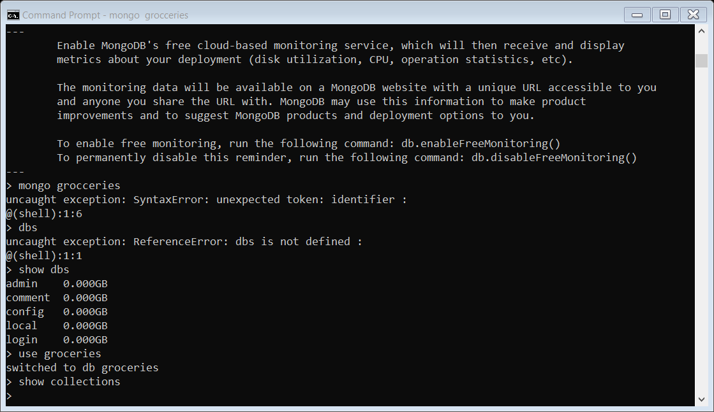MongoDB Running

Localhost 8080

Create Item

Create 2nd Item

Update Item

Delete Item

Delete Item CMD PROMT INPUT

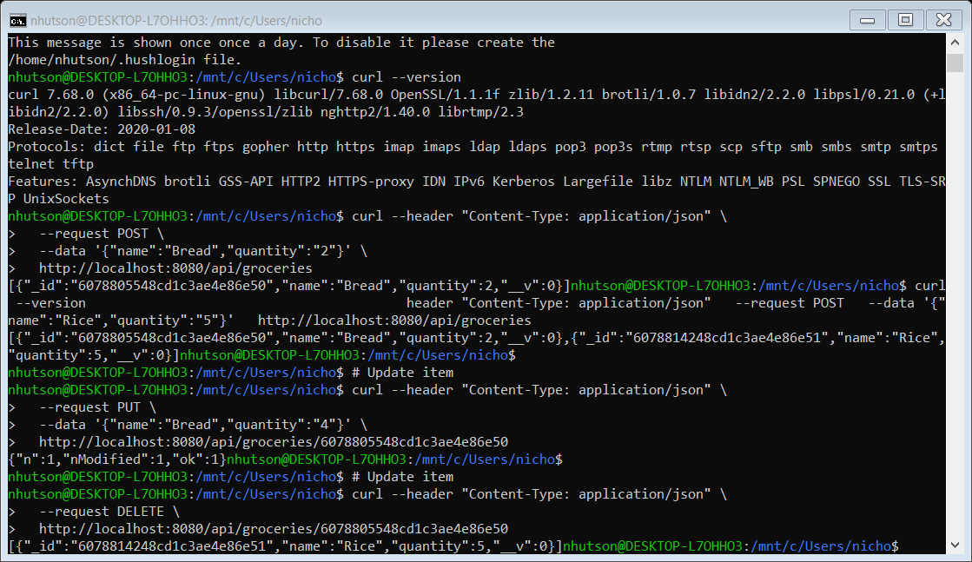

App View

ADD Item

